**GREEN TOWNSHIP BOARD OF EDUCATION**

**MINUTES**

**Regular Meeting**

**June 12, 2024**

**Time: 7:00 p.m. ` Place: Green Hills School - Library**

**I**. **CALL TO ORDER**

**A. FLAG SALUTE-led by President Bilik**

**B. OPEN PUBLIC MEETINGS ACT STATEMENT-Read by President Bilik**

“This is a regular meeting of the Green Township Board of Education held for the purpose of transacting appropriate Board business. In compliance with Chapter 31, Laws of 1975, the New Jersey Herald was properly notified and copies of the agenda of this meeting were appropriately posted and made available for the public.”

**C. ROLL CALL**

Term Roll Call

|  |  |  |  |
| --- | --- | --- | --- |
| Mr. | CJ Bilik | 2024 | Present |
| Mrs. | Marie Bilik | 2026 | Present |
| Mrs. | Ann Marie Cooke | 2024 | Present |
| Ms.. | Crystal Bockbader | 2025 | Present |
| Ms. | Kristin Post | 2024 | Present |
| Ms. | Maureen McGuire | 2026 | Present |
| Ms. | Holly Roller | 2025 | Present |
| Dr. | Melissa Vela | 2026 | Present |
|  | Vacant BOE Seat | 2025 |  |
|  |  |  |  |
| Dr. | Jennifer Cenatiempo, Superintendent |  | Present |
| Mrs. | Karen Constantino, SBA |  | Present |

**D. Mission-**Read by Karen Constantino

Green Township School District educates every student to become a confident and caring life-long learner who communicates effectively and contributes positively to the evolving needs of society. The district, in partnership with the community, promotes academic excellence and equitable opportunities for all students.

Motion to amend the agenda as written with the addendum

Motion-Dr. Vela Second-Mrs. Bockbrader

BOE members responded “aye” with an “all in favor”.

**II**.  **PRESENTATIONS**

**a.) HIB Grade Reports Presented by Mr. Bollette**

Mr. Bollette reviewed the HIB self assessment, earned 75/78 points for the 22-23SY

-exceeded requirements (Presentation listed in attachments)

**b.) Presentation of the New Jersey Consortium of Gifted & Talented Program 1st Place Winners for the Rube Goldberg Machine Structure Projects:**

**Cortland Martin**

**Ethan Costabel**

**Archie Wenner**

**Jack Pagatto**

**Luke Cole**

**-**Mrs. DeNuto and her students spoke about their determination and perseverance for this project. A video

of their project was shared. Dr. Cenatiempo told the students how proud of them she was. Students shared

their thoughts about the project.

**c.) Bicentennial Celebration Presentation presented by Dr. Jennifer Cenatiempo**

-Nearly 200 projects, and artifacts from over 100 years ago, packed house, students were excited and proud

of their township, video shown that featured many of the projects that night

-Thanked Mrs. DeNuto and Mr. Wynne for their leadership, support from the faculty and staff was

extensive

**Resolution**-Read by Mrs. Ann Marie Cooke

**IN RECOGNITION AND APPRECIATION FOR:**

Dr. Noah Haiduc-Dale

**WHEREAS**, the Green Township Board of Education consists of a nine member board; and

**WHEREAS**, Dr. Noah Haiduc-Dale has served on the Green Township Board of Education for

more than eight years; and

**WHEREAS**, the Green Township Board of Education gratefully acknowledges Dr. Haiduc-Dale’s

superior commitment, dedication and leadership; and

**WHEREAS**, the Green Township Board of Education would like to acknowledge Dr. Haiduc-

Dale’s outstanding service as both a board member and member of the Board’s Policy, Personnel,

Curriculum, Climate and Tri-District Consortium Committees; and

**WHEREAS**, the Board of Education is the governing body for the Green Township School

District; now

**THEREFORE BE IT RESOLVED**, that the Green Township Board of Education acknowledges

The hard work and dedication of Dr. Haiduc-Dale.

**BE IT FURTHER RESOLVED**, that with the enactment of this resolution, Dr. Haiduc-Dale’s

Resolution shall be so noted in the minutes and become a part of the permanent record of the Green

Township School District; and

**BE IT FINALLY RESOLVED**, that the Green Township Board of Education honors its colleague

And friend, Dr. Noah Haiduc-Dale’s, for his exemplary service to education on behalf of the citizens of

Green Township.

This resolution shall take effect immediately.

Adopted this 12th day of June, 2024

-President Bilik recognized Dr. Haiduc-Dale for his service and a certificate of appreciation was presented to him in addition to books that will be donated in his name to the school library. Dr. Haiduc-Dale spoke about how he became involved with the BOE, and his experience. The BOE thanked him for his many years of service.

**III. CORRESPONDENCE**-None

**IV. PUBLIC PARTICIPATION ON AGENDA TOPICS-**None at 7:36pm

This public session is designed for members of the public to speak on agenda items pertaining to the Green Hills School District. By law, the Board of Education is under no obligation to respond to public comment. If the Board of Education chooses to respond, it does not waive it’s right thereafter not to respond. Each statement made by a participant shall be limited to three (3) minutes in duration as timed by the Board of Education Vice President. Comments regarding students and employees of the Board are discouraged and will not be responded to by the Board. Students and employees have specific legal rights afforded by the laws of New Jersey. No participant may speak more than once during each public comment session. The speaker must address the President and not individual Board Members, the Superintendent or the audience. Please state your first and last name and address for the record.

# **V. VARIOUS REPORTS**

A. NEWTON BOARD OF EDUCATION UPDATE - Mrs. Cooke

**Superintendent’s Report:** 2022-2023 NJDOE HIB Self-Assessment (available on website)

**School Business Administrator/ Board Secretary’s Report:** Science Lab Renovation anticipated completion August 20th.

**Board Business:** Approved staff appointments for 2024-2025 school year.  
Approved job description for *Assistant Superintendent of Business*.

Approved the change of position name from Business Administrator/Board Secretary to Assistant Superintendent of Business effective July 1, 2024.

Accepted the resignation of Elysia Caraballo, Director of Community Schools, effective July 13, 2024.

**Next Meeting:** June 25, 2024 at 7 pm

B. PTA UPDATE - Mrs. Post

-No Meeting since we last met

-Had a tremendous field day, great activities, successful

-Had popsicles on the playground

C. BOARD PRESIDENT’S REPORT - Mrs. Bilik

-Attended the Bicentennial celebration, many projects, large turnout…thank you to Mr. Bird, Mrs. DeNuto,

Mr. Wynne, Mrs. O’Connor, Mr. Bollette and all staff

-5/20 Student Government Day

-5/22 attended Warren County School Boards Meeting-a member was honored for 55 years of service

-5/29 attended Newton High School Concert

-6/1 Attended Green Township Day, 6/3 Shakespeare in the Park, 6/5 Newton Senior Awards night

-6/10 attended Holocaust Presentation by Marion Blumenthal Lazan…where students had insightful

questions

-Attended the final climate/culture committee

D. SUPERINTENDENT’S REPORT - Dr. Cenatiempo

HIB: There was 1 unfounded HIB Case to report since the June 4, 2024 BOE meeting.

Drills: Fire Drill   
 Lockdown Drill

-wrapping up the end of the year

-attended Shakespeare in the Park, purchased a minivan, successful Washington D.C. trip for grade 8

-Literacy training continues …Morphology continues for 8 staff members, phonological awareness training

-Parent engagement sessions, wax museum, field day event and student government day

-Thank you for bringing Mrs. Blumenthal…all moved to hear her story, students were exemplary

-Completed Title I Engagement Series with parent, students and provided dinner-participants enjoyed

-Graduation will be on Friday evening at 7pm

-Fire drill on 6/12, lockdown on 6/10, and one unfounded HIB

E. BUSINESS ADMINISTRATOR/BOARD SECRETARY’S REPORT - Mrs. Constantino

-Purchased minivan, sent to company to get it “school ready”

-Open enrollment for staff ended 5/31 for health insurance

-EBT Benefits were filed for those eligible families

-Attended NJASBO conference in Atlantic City for professional development classes

**VI. DISCUSSION ACTION ITEMS**

A. Discussion and Impact of P.L 2024 c.13 Stabilized Budget Aid and P.L.2024 c.12: Extended

Budget Deadlines

-Dr. Cenatiempo discussed options: Take $0 and hold; suggested .8 health/p/e teacher ($60K), .8 math

Interventionsist ($60K), and 60 new chromebooks and smarboards ($30k)

-Board members discussed the options, to be responsible to the school and the taxpayer. Want to balance

the needs of the school while not overtaxing the tax payer. Approx 400 of the 1200 families in Green have

students

-Mrs. Cooke mentioned that with the CPI increasing, election in November, and everything asked of the

Taxpayer-No increase-people are struggling right now

Straw poll taken: 4 members were for and 4 members were against increasing the levy

-Discussed meeting the mandate for health/pe, 150 minutes, impact of reassessment of homes, tough

decision as the formula for state aid is unknown

Motion to increase the tax levy by an additional $150,000 for the 2024-2025 school year to add two .8

teachers, one 4/5 math interventionist and one 4/5 health/p/e teacher, and $30k for

chromebooks/smartboard/technology.

Motion-Mrs. Post Second-Mrs. McGuire

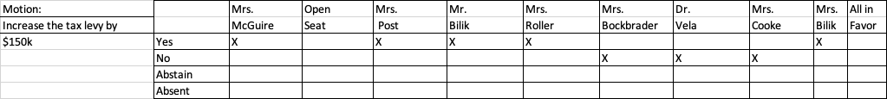

-Motion Passes

**VII. BOARD BUSINESS** - Mrs. Ann Marie Cooke

A. Motion to accept minutes of the following meetings:

1. Special Meeting of June 4, 2024. (Attachment)

2. Executive Session of June 4, 2024

3. Executive Session of May 15, 2024

4. Regular Meeting Minutes of May 15, 2024

B. Motion to accept the HIB Reports from the June 4, 2024 meeting.

Motion-Mrs. Cooke Second- Dr. Vela

/Roll Call/

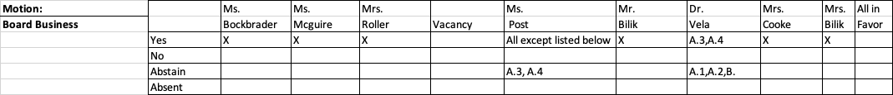

**VIII. UNFINISHED BUSINESS**

It was the consensus of the board that the original window of opportunity to apply for the board vacancy did not provide sufficient timeframes for notifications and response. Therefore, we extended the time line to send a letter of interest through the close of business on June 17th and expanded our notification medias.

There will be a special meeting of the board on June 19th to finalize any additional interviews, hold board deliberations, with an appointment at the conclusion of that meeting. The first interviewed candidate is still viable.

-Complete Board Self-Evaluation

**IX. NEW BUSINESS-**None

**X. COMMITTEE REPORTS**

**A. CURRICULUM** - Mrs. Maureen McGuire, Chairperson

1. Motion to approve the following professional development request(s):

|  |  |  |  |  |
| --- | --- | --- | --- | --- |
| **Staff Member** | **Conference Name** | **Provider/Location** | **Date** | **Costs** |
| Michael Housel | NJSGBA North / South Facilities Training | Mount Olive High School  18 Corey Road  Flanders, NJ | 7/16/24 | No cost to the BOE |

Motion- Maureen McGuire Second- Mr. Bilik

/Roll Call/

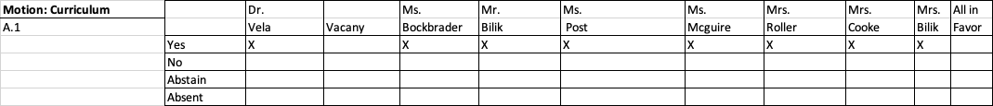

**B. FINANCE** - Ms Kristen Post, Chairperson

**May 2024 Financial Reports (attachment)**

1. Motion to approve the General Fund bills list for May 16, 2024 through June 12, 2024

for a total of $979,486.92 (attachment)

2. Motion to accept the Board Secretary’s monthly certification, as attached, and that as of May 31, 2024, no line item account has encumbrances and expenditures, which in total exceed the line

item appropriation in violation of N.J.A.C.6A:23A-16.10(c)3.

3. Pursuant to N.J.A.C. the Green Township School District Board of Education, after

review of the Board Secretary’s and Treasurer’s monthly financial reports certify that as of May 31, 2024 and upon consultation with the appropriate district officials, to the best of our knowledge, no major account or fund has been over expended in violation of N.J.A.C. 6A:23-16.10(c)4 and that sufficient funds are available to meet the district's financial obligations for the remainder of the fiscal year.

4. Motion to accept the financial reports from the Board Secretary and the Treasurer of

School Monies for the month of May, 2024.

5. Motion to approve transfers for May, 2024.

6. Motion to approve the disbursements from May 16, 2024 through June 12, 2024

for the Student Activities Account in the amount of $15,529.87 and the Business

Office Petty Cash Account in the amount of $140.00 **(attachment)**

7. Motion to approve the non-refundable deposit of $1,500 to YMCA Camp Mason for the Fall 2024 field trip.

8. Motion to approve the Parental Contract for Student Transportation for a contract term of 10

months at total contract amount of $22,400 for the 24-25 school year, payable in 10 equal

installments, for student id# ending 2353.

9. Motion to revise the May 15, 2024 minutes to reflect the removal of the last sentence of motion 12

under finance, “This contract is contingent upon and could be modified based on student

participation and the district’s receipt of sufficient State School Aid and other revenue funding.”

10. Motion to approve Maschio’s Trucking, LLC delivery service agreement for the 2024-2025 school year, starting on July 1, 2024 through June 30, 2025, with the following payment terms:

$149.95 for delivery of 1 to 49 cases, a flat rate of $3.95 will be charged for each delivered case exceeding 49 cases. An additional amount of $20.00 for each stop will be charged for multiple deliveries within the customer’s district. Additionally, a fuel surcharge of $10.95 per delivery may be charged. MT will provide customer with monthly billing statements and customer will submit payment to MT within 30 days of statement date. MT will charge $0.75 per case, per month, for offsite storage.

11. Motion to approve the Maschio’s Price list for the 24-25 SY (attachment)

12. Motion to approve the annual public bid threshold rates for the 2024-2025 school year as follows:

With Qualified Purchasing Agent - $44,000

Without Qualified Purchasing Agent - $32,000

13. Motion to approve additional funding of the Capital Reserve Account in an amount up to

$650,000 as of June 30, 2024. The source of these funds are derived from anticipated surplus

realized at the conclusion of the 2023-2024 fiscal year.

14. Motion to approve additional funding of the Maintenance Reserve Account in an amount up to

$350,000 as of June 30, 2024. The source of these funds are derived from anticipated

surplus realized at the conclusion of the 2023-2024 fiscal year.

15. Motion to approve additional funding of the Tuition Reserve Account in an amount

up to $350,000 as of June 30, 2024. The source of these funds are derived from anticipated surplus realized at the conclusion of the 2023-2024 fiscal year.

16. Motion to change the capital project listed below in the 24-25 school budget as follows:

From: $50,000 of stair repairs

To: $25,000 Stair Repairs and $25,000 New Gym Speaker System (to be funded out of the the

capital reserve)

Motion – Mrs. Post Second – Mrs. Bockbrader

/Roll Call/

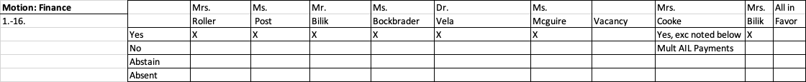

**C. OPERATIONS** - Mr. CJ Bilik, Chairperson

` 1. Motion to return $8,462 back to the maintenance reserve for funds that were not needed, due to

receiving SDA grant funds in the amount of $8,462 for capital maintenance needs.

Motion – Mr. Bilik Second – Mrs. McGuire

/Roll Call/

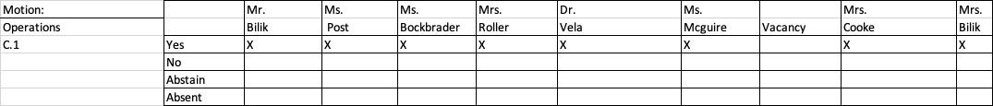

**D. PERSONNEL** - Ms. Crystal Bockbrader, Chairperson

1. Motion to approve sick day retirement payouts for employee IDs:

|  |  |
| --- | --- |
| Employee ID | Number of Days at $70/day |
| G0000544 | Up to 125 days at $70/day=$8,750 |
| G0000591 | Up to 125 days at $70/day=$8,750 |

2. Motion to approve the School Business Administrator’s contract for the 24-25 SY.

3. Motion to approve Kelli McKeown s as Preschool / Kindergarten teacher for the ESY program for identified learners for the 2024-2025 school year, at her hourly contracted rate, from 9:00 am to 12:00 pm, on the following dates; pending criminal background check and paperwork, at the recommendation of the Superintendent:

| 7/8/24, 7/9/24, 7/10/24, 7/11/24, 7/12/24 |
| --- |
| 7/15/24, 7/16/24, 7/17/24, 7/18/24, 7/19/24 |
| 7/22/24, 7/23/24, 7/24/24, 7/25/24, 7/26/24 |
| 7/29/24, 7/30/24, 7/31/24, 8/1/24, 8/2/24 |

4. Motion to approve Diane Parker and Ana Velez as paraprofessionals for the ESY program for identified learners for the 2024- 2025 school year, at a rate of $15.13 per hour, from 9:00 am to 12:00 PM, on the following dates, at the recommendation of the Superintendent: :

| 7/8/24, 7/9/24, 7/10/24, 7/11/24, 7/12/24 |
| --- |
| 7/15/24, 7/16/24, 7/17/24, 7/18/24, 7/19/24 |
| 7/22/24, 7/23/24, 7/24/24, 7/25/24, 7/26/24 |
| 7/29/24, 7/30/24, 7/31/24, 8/1/24, 8/2/24 |

5. Motion to approve Olivia Sanchez as a paraprofessional for the ESY program for identified learners for the 2024-2025 school year, at a rate of $15.13 per hour, from 9:00 am to 12:00 pm, on the following dates; pending criminal background check and paperwork, at the recommendation of the Superintendent:

| 7/9/24, 7/10/24, 7/11/24 |
| --- |
| 7/16/24, 7/17/24, 7/18/24 |
| 7/23/24, 7/24/24, 7/25/24 |
| 7/30/24, 7/31/24, 8/1/24 |

6. Motion to approve Brianna Parker as ESY Teacher for the 2024-2025 school year, from July 8, 2024 through August 2, 2024, at BA - Step 1, at the hourly contracted rate, with no benefits, from

July 8, 2024 through August 2, 2024 from 9:00 am - 12:00 pending documentation, as

recommended by the Superintendent.

7. Motion to approve Kaitlyn Denz, ESY Teacher for the 2024-2025 school year, from July 8, 2024 through August 2, 2024 (Tuesdays, Wednesdays & Thursdays), at BA - Step 1, at an

hourly rate of $48.66, with no benefits, from July 8, 2024 through August 2, 2024 from 9:00 am - 12:00 pending documentation, as recommended by the Superintendent.

8. Motion to approve Marybeth Stiles the 504 Coordinator, for the 24/25 school year, as

recommended by the Superintendent.

9. Motion to appoint Tiffany Lutz as McKinney Vento Homeless Liaison, for the 24/25 school

year.

10. Motion to appoint Jon Paul Bollette as the Title IX Investigator.

11. Motion to appoint Marybeth Stiles as the Title IX Coordinator.

12. Motion to appoint Jennifer Cenatiempo as the Title IX Decision Maker.

13. Motion to appoint Jillian Montanaro as School Psychologist for the 2024 - 2025 school year, at Step 2 MA, at a salary of $71,777, pending documentation, as recommended by the Superintendent.

14. Motion to approve Jillian Montanaro, School Psychologist for the 2024 summer work schedule, for 20 hours, at her hourly contracted rate, as recommended by the Superintendent.

15. Motion to approve Lori Naomi as substitute school nurse for the 2024-2025 school year, pending documentation, as recommended by the Superintendent.

16. Motion to approve Jayne Rymut, ESY Speech and Language Specialist, at a rate of $89/hour, for a

total of 24 hours and a total cost of $2,136 to be paid out of the general fund, at the approval of the Superintendent, pending completion of fingerprints and all relevant paperwork.

Motion – Mrs. Bockbrader Second – Dr. Vela

/Roll Call/

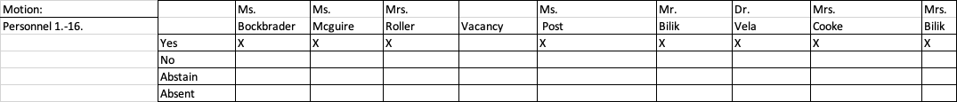

**E. POLICY** - Ms. Holly Roller, Chairperson

**XI. REAPPOINTMENT BUSINESS – SUMMARY MOTIONS**

1. Motion to appoint Linda DiLorenzo as Treasurer of School Funds for the ensuing year,

2024-2025, at a salary of $5,483.78

2. Motion to appoint Karen Constantino as Board Secretary for the 2024-2025 fiscal year.

3. Motion to appoint Allison M. Peck, P.T. for physical therapy services for the 2024-2025 fiscal

year at a rate of $ 89.00/hour.

Motion - Mrs. Cooke Second – Dr. VanBlarcom

/Roll Call/

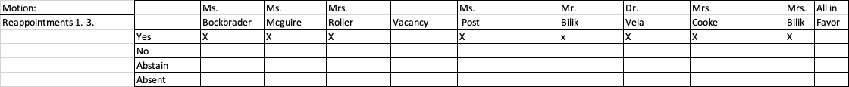

Bank and Financial Designations – Agenda items 4 - 13

4. Motion to designate TD Bank as the depository for the following accounts:

Operating

Payroll

Agency

Petty Cash

Unemployment

EscrowDirect

Bond/Construction Account

Child Care

FSA Account

5. Motion to designate Lakeland Bank as the depository for the following accounts:

Student Activity

Cafeteria

6. Motion to authorize the signatories as follows:

|  |  |  |
| --- | --- | --- |
| BANK | DESCRIPTION | SIGNATORIES |
| TD Bank | Operating (Treasurer) | (3) President or Vice-President  Board Secretary and Board Treasurer  *Alternate Signatories:  Vice President for President; Superintendent or Operations Chair for Board Secretary |
| TD Bank | Payroll | (1)Board Treasurer or Board Secretary |
| TD Bank | Payroll Agency | (1)Board Treasurer or Board Secretary |
| Lakeland Bank (Provident) | Student Activity | (1) Board Secretary or Superintendent |
| TD Bank  TD Bank | Petty Cash  Unemployment Fund | (1) Board Secretary  (1) Board Secretary |
| TD Bank | Escrow Direct | (1) Board Secretary |
| Lakeland Bank | Cafeteria | (1) Board Secretary |
| TD Bank | Bond/Construction | (1) Board Secretary |
| TD Bank | Child Care | (1) Board Secretary |
| TD Bank | FSA Account | (1) Board Secretary or Superintendent |

7. Motion to approve the use of facsimile signatures with the verbal permission of the signatories.

8. Motion to approve authorization of the Board Secretary/Business Administrator to invest the

funds of the Board at the most advantageous rate and institution in compliance with all state laws

and regulations.

9. Motion to permit the Board Secretary/Business Administrator to audit and approve any account

and demand for payment prior to presentation to the Board up to $500 and interfund payroll reimbursements for the cafeteria and child care enterprise funds. Any such approval shall be presented to the Board for ratification at their next meeting as per NJSA 18A:19-4.1. Anticipated payments in excess of the $500 that might occur in the time frame after the board meeting but before the next Board meeting will be approved by a Board motion for a dollar amount not to exceed.

10. Motion to approve the renewal of the establishment of a Board Secretary’s petty cash checking

account for 2024-2025 in the amount of $350.00 to be used for general office expense, workshops/seminars and other items requiring payment in advance and limited to $150.00 or under per expenditure as per policy #6620.

11. Motion to approve Superintendent’s petty cash for 2024-2025 in the amount of $200.00 to be

distributed as cash with a $150.00 maximum per expenditure as per Green Township Board of Education policy #6620.

12. Motion to approve the bonding of the Board Secretary, Treasurer of School Monies and all other

employees as deemed necessary for the 2024-2025 school year as per State Law requirements.

13. Motion to approve Karen Constantino as Public Agency Compliance Officer. The P.A.C.O. is the

liaison between the Division and the Public Agency and is the Public Agency point of contact for all matters concerning implementation and administration of the statute. The P.A.C.O. is also responsible for administering contracting procedures pertaining to equal employment opportunity regarding both the Public Agency and the service providers. The service provider shall include but shall not be limited to goods and services vendors, professional service vendors and construction contractors. As such, the P.A.C.O. must have the authority to recommend changes to effectively support the implementation of the statute and its regulations.

Motion – Mrs. Cooke Second – Mrs. Post

/Roll Call/

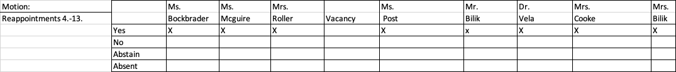

Board Business Designations – Agenda items 14 - 16

14. Motion to designate the following as legal newspapers for legal notices and advertising:

New Jersey Herald (Primary)

Township Journal – Straus News (Secondary)

15. Motion to approve the following locations for posting all legal notices:

Greendell Post Office

Tranquility Post Office

Green Hills School

Green Township Board Office

Green Township Municipal Building

16. Motion to operate as a Board under the committee system comprised of the following

committees:

Curriculum

Finance

Negotiations

Operations

Personnel

Policy

Tri-District Committee

Motion – Mrs. Cooke Second – Dr. Vela

/Roll Call/

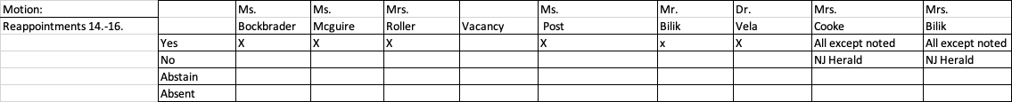

Procedure Designations – Agenda Items 17 - 19

17. Motion to approve a fee of the current postage rate and cost per page not to exceed the amount as

set by the Open Public Meeting Act 47: A-2 (OPRA).

18. Motion to authorize the Superintendent and Business Administrator to approve such budget

transfers that are necessary between board meetings.

19. Motion to authorize the Board Secretary/Business Administrator to advertise for and receive bids

for supplies, equipment, and services for the 2024-2025 school year when required by the Public School Contracts Law.

Appointment of Professionals

20. Motion to approve the following individuals or firms in their respective positions for the

2024-2025 school year:

a. Energy Cooperation ACES

b. School Physicians Dr. Sanjay Jain & Dr. Freeman

c. Insurance Fund School Alliance Insurance Fund (SAIF)

d. Parette Somjen Architects LLC (PSA) District Architect

e. Environmental Consultants RK Occupational & Environmental Analysis, Inc.

f. Board Attorney Schenck, Price, Smith & King

g. Bond Attorney McManimon & Scotland, L.L.C.

h. Board Auditor Nisivoccia & Co., L.L.P.

i. Accounting Software Provider CDK Systems

j. Payroll Computer Service Provider R & L Datacenters, Inc.

k. Insurance Agent of Record The Morville Agency

l. Medical Insurance Agent of Record Brown & Brown Benefit Advisors

21. Motion to appoint Jon Paul Bollette as Affirmative Action Officer for Green Hills School for the

2024-2025 school year, with no additional stipends or salary.

22. Motion to appoint Jon Paul Bollette as Attendance Officer for Green Hills School for the

2024-2025 school year, with no additional stipends or salary.

23. Motion to appoint Jon Paul Bollette as School Safety Specialist for Green Hills School for the

2024-2025 school year with no additional stipends or salary.

24. Motion to adopt all existing Board policies, textbooks, administrative regulations, library books

and curriculum for the 2024-2025 school year which have been in effect during the present school year, subject to revision and constant review by the Board of Education.

25. Motion to allow the following tax shelter investment carriers to market their product to the

employees. Investments may be made through payroll deductions at employee’s request.

AXA – Equitable 403B

The Equitable Company

Security Benefit

Motion – Mrs. Cooke Second – Mrs. Post

/Roll Call/

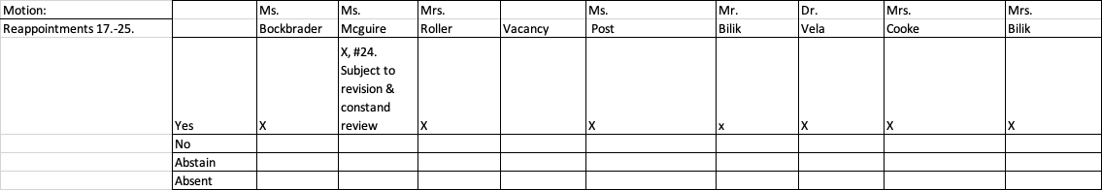

**XII. PUBLIC PARTICIPATION ON NEW BUSINESS TOPICS** at 8:45pm

This public session is designed for members of the public to speak on agenda items pertaining to the Green Hills School District. By law, the Board of Education is under no obligation to respond to public comment. If the Board of Education chooses to respond, it does not waive it’s right thereafter not to respond. Each statement made by a participant shall be limited to three (3) minutes in duration as timed by the Board of Education Vice President. Comments regarding students and employees of the Board are discouraged and will not be responded to by the Board. Students and employees have specific legal rights afforded by the laws of New Jersey. No participant may speak more than once during each public comment session. The speaker must address the President and not individual Board Members, the Superintendent or the audience. Please state your first and last name and address for the record.

-Dr. Jake Mull-13 Summit Road

-2 people from public interviewed for the BOE seat and the second person dropped out

-did not accept that person that night

-President Bilik stated that by law the BOE has 65 days

-My Mull asked why, and it doesn’t look good at all

-Amy Munoz-17 Shotwell Road-saw we have the Lifevac for choking…could we set up one closer to the cafeteria

Public comment closed at 8:48pm

**XIII. CLOSED MEETING**

Closed Meeting Motion was read by President Bilik at 8:49pm.

The Board of Education of the Green Township School District in the County of Sussex will adjourn into closed meeting to discuss item(s) which fall within an exception of our open meetings policy and permits the Board to have private discussion, since it deals with specific exceptions contained in

a Matters rendered confidential by Federal Law, State Law, or Court Rule

**b Individual privacy**

c Collective bargaining agreements

d Purchase or lease of real property if public interest could be adversely affected

e Investment of public funds if public interest could be adversely affected

f Tactics or techniques utilized in protecting public safety and property

**g Pending or anticipated litigation**

h Attorney-client privilege

**i Personnel–employment matters affecting a specific prospective or current employee**

Be it resolved that the Board will now go into private session to discuss matters rendered confidential due to the nature of pending or anticipated litigation, attorney-client privilege and personnel – employment matters affecting a specific prospective or current employee privilege. Any discussion held by the Board, which need not remain confidential, will be made public as soon as practical. Minutes of the private session will not be disclosed until the need for confidentiality no longer exists. All appropriate persons, who may be discussed in private session, have been adequately notified.

Motion to enter into executive session for the purpose of discussing “b”, “g”, and “i”

**No action will be taken after executive**

Motion – Dr. Vela Second – Mr. Bilik

Roll Call/

**XIV. RECONVENE**

Motion to reconvene into public session at 9:45pm.

Motion – Mrs. McGuire Second – Mr. Bilik

/Roll Call/

All BOE members responded “aye” to all in favor.

**XV. BOARD COMMENTS-None**

**XVI. ADJOURNMENT**

Motion that the Board of Education shall adjourn at 10:04pm.

Motion – Mrs. McGuire Second – Mr. Bilik

/Roll Call/

All BOE members responded “aye” to all in favor.

**Next Meeting Date:**

June 19, 2024, Special Meeting

**Vision**

Empower students and staff to embrace their individual strengths in a safe,

supportive environment that fosters a love of learning while pursuing their full potential.